**MOBILE APP QUERIES**

1. Will this change the XML response which is returned from Find Programs/Find Coupons feature?

-No, the XML still the same.

2. Will it have the same program with multiple nodes but with different locationId attribute?

-Yes, however you don’t need to worry on displaying them. There’s no need to for you to apply distinct algorithm.

3. When the data is returned to mobile app we need to show the distinct program based on PID which means if there are multple nodes with same PID but different locationId they will be listed as a single program. Please confirm. Is it applicable to Coupons also?

-Yes. At the front end it displays as 1 item which actually in the XML it is multiple. Thus, it is no longer applicable on Coupon. Remember, only on My Program list, distinct method is applicable.

4. Do I need to store local data also in multiple program nodes but shown as a single record in My Programs?

-No! As long as the same program though in different locations still they are the same program. So data will be store locally at once.

5. During Sync I will return the same XML with multiple programs to server? Is that correct or I need to send with distinct data values?

-Yes, return the same XML with multiple programs.

6. Can you send some sample XML for me to review and plan its implementation?

-The best thing I can give you on this, is to visit this link:

<http://loyalaz.com/loyalaz_mobile/> , this is the mobile emulator we are currently using in interacting the latest features on LoyalAZ. This emulator is already equipped with Multilocation features. This is the XML of the emulator: <http://www.loyalaz.com/loyalaz_mobile/XMLDB/XMLDB.xml>

Scan

1. Existing QR codes will not have additional parameters and they will run as is. Please confirm.

-Yes, nothing is added

2. If there is additional parameter in QR code and program is scanned on two different locations app will always create 2 different nodes in XML but total point balance will be some of both the locations? Correct?

-There is no additional parameter in QR code.

3. Can you send a sample QR code?

These 2 codes are of the same program but in different locations.

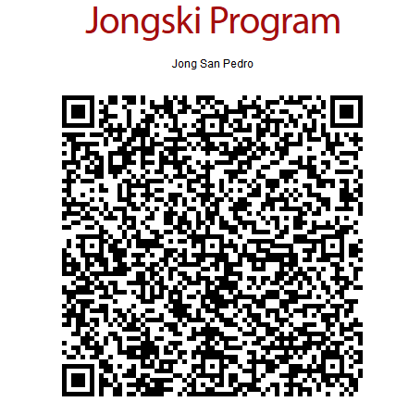

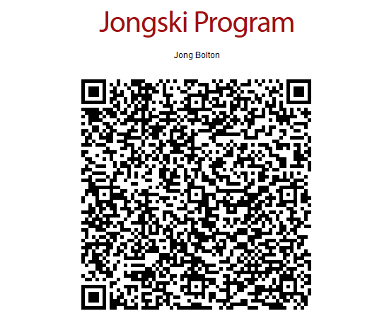

4. Is it possible to have two different locations having different pt_target values for same program?

-No, it’s not possible.